# Real-Time Log Analysis Using Hadoop and Spark

## Table of Contents

1. Abstract
2. Introduction
3. Problem Statement
4. Literature Review
5. Architecture & Technology Stack
6. Dataset Description
7. Detailed Algorithm & System Flow
8. Implementation Approach & Code Snippets
9. Output & Sample Results
10. Conclusion & Future Work
11. References

## 1. Abstract

Modern organizations face challenges with **massive, fast, and diverse log data** that conventional analytic tools can't handle. This project, "Real-Time Log Analysis Using Hadoop and Spark," creates a distributed pipeline for **collecting, ingesting, processing, and aggregating logs** using **Apache Kafka/Flume, Hadoop HDFS, and Apache Spark Streaming**. The system performs **real-time trend detection, anomaly alerting, and generates actionable operational dashboards** through scalable computation and storage, providing a foundation for continuous monitoring and rapid incident response.

## 2. Introduction

**Log data** is crucial for understanding system behavior and health. However, the **increasing scale and velocity of log streams** overwhelm traditional batch analytics, causing delays in detecting incidents, security threats, and operational issues. This project uses **Hadoop's scalable storage** and **Spark's real-time streaming engine** to build a flexible, high-performance pipeline for live log analytics. The solution provides **low-latency insights, early warnings, and historical reporting**, enabling proactive infrastructure and user experience management.

## 3. Problem Statement

Traditional logging infrastructures face several key challenges:

* **Scalability**: Inability to manage thousands or millions of log events per second from various sources.
* **Latency**: Slow ETL and batch jobs cause significant delays in critical incident detection.
* **Diversity**: Logs from applications, servers, and devices have differing formats and semantics.
* **Operational Insight**: Difficulty in real-time identification of trends, spikes, and anomalies across distributed systems.
* **Storage & Query**: The need for both immediate streaming analytics and historical batch queries over long periods.

The project aims to address these issues by designing a **distributed system** with real-time streaming, scalable storage, and live analysis and alerting capabilities.

## 4. Literature Review

Industry and academic literature highlights the necessity for **distributed, stream-based analytics** in operational monitoring:

* **Distributed Log Ingestion**: **Kafka and Flume** are recognized for high-throughput, fault-tolerant log streaming.
* **Stream Analytics**: **Apache Spark Streaming** and similar frameworks enable micro-batch, continuous computation as data arrives.
* **Operational Visualization**: **Elasticsearch, Kibana, and Grafana** are standard tools for live dashboards and exploratory data analysis.
* **Research Findings**: Studies confirm that **windowed aggregations, alert thresholds, and automated anomaly detection** significantly improve the speed of detecting and remediating outages, attacks, or SLA breaches compared to batch architectures.

## 5. Architecture & Technology Stack

### System Design

|  |  |  |
| --- | --- | --- |
| Layer | Technology | Role |
| Ingestion | Kafka / Flume | Distributed real-time log shipping |
| Storage | HDFS, Hive | Durable, scalable log storage |
| Processing | Spark Structured Streaming | Real-time parsing, filtering, aggregation |
| Visualization | Grafana, Kibana | Dashboards and trend graphs |
| Machine Learning | Spark MLlib (optional) | Anomaly detection, event clustering |

### System Flow

1. **Log Collection**: Logs from web, application, and system sources are ingested in real-time via **Kafka or Flume**.
2. **Distributed Storage**: All logs are initially stored in **Hadoop HDFS**, partitioned by timestamp.
3. **Stream Processing**: **Spark Streaming** consumes logs from Kafka, then parses, filters, and aggregates data in sliding windows to support operational metrics and anomaly detection.
4. **Result Storage**: Aggregated data is saved to **Hive** for ad hoc SQL queries, with summaries optionally sent to **Elasticsearch** for live visualization.
5. **Visualization**: Real-time and historical dashboards are built using **Hive, Elasticsearch**, or other tools.
6. **Alerting**: Thresholds and anomaly detection algorithms trigger alerts for incident response.

## 6. Dataset Description

### Data Sources

* **Web Server Logs**: Include fields such as timestamp, IP, URL, HTTP method, status code, and user agent.
* **Application Logs**: Contain transaction events, error messages, and custom activity.
* **System Logs**: Provide CPU/memory/disk metrics and syslog information.

### Sample Schema

|  |  |  |  |  |  |
| --- | --- | --- | --- | --- | --- |
| timestamp | ip | method | url | status | user_agent |
| 2025-07-19 10:00:00 | 192.168.1.1 | GET | /home | 200 | Mozilla/5.0 |
| ... | ... | ... | ... | ... | ... |

Logs are ingested as either text or CSV/JSON and then parsed into this standardized structure for subsequent analysis.

## 7. Detailed Algorithm & System Flow

### Summarized System Steps

1. **Data Collection**
   * Identify log sources (web, app, system).
   * Configure **Kafka/Flume** for real-time collection and shipping to central topics/channels.
2. **Ingestion in Spark**
   * A **Spark Structured Streaming job** subscribes to the Kafka/Flume stream.
   * Logs are read in small intervals (e.g., every 5–10 seconds).
   * Raw logs are parsed into structured fields using regex or schema mapping.
3. **Processing & Transformation**
   * Logs are filtered by error conditions (e.g., status >= 400 or ERROR keyword).
   * Fields are extracted and enriched with context (e.g., GeoIP, user-agent analysis).
   * Data is aggregated with windowing (e.g., 10-minute sliding window) to compute metrics like request count, error rate, and top URLs/IPs.
4. **Analysis & Anomaly Detection**
   * Current metrics are compared to historical averages to identify spikes or anomalies.
   * (Optional) **Spark MLlib** can be used for unsupervised detection of unusual patterns.
5. **Persistence**
   * Both raw and processed logs are stored in **HDFS**.
   * Aggregates are saved to **Hive tables**, partitioned by time, for SQL analytics.
6. **Visualization & Reporting**
   * Dashboards query **Hive, Elasticsearch**, or direct Spark outputs for real-time/top-N metrics, error rates, and usage trends.
   * Alerts are triggered if error rates or traffic exceed defined thresholds.

### Main Outputs

* Aggregated metrics (minute/hour/day)
* Lists of top URLs/IPs
* Anomaly and alert logs
* Visual and exported reports

## 8. Implementation Approach & Code Snippets

### Environment Setup

Python

# Install Java, Spark, findspark  
!apt-get install openjdk-11-jdk-headless -qq > /dev/null  
!wget -q https://archive.apache.org/dist/spark/spark-3.5.0/spark-3.5.0-bin-hadoop3.tgz  
!tar xf spark-3.5.0-bin-hadoop3.tgz  
!pip install -q findspark  
  
import os  
os.environ["JAVA_HOME"] = "/usr/lib/jvm/java-11-openjdk-amd64"  
os.environ["SPARK_HOME"] = "/content/spark-3.5.0-bin-hadoop3"  
import findspark; findspark.init()  
from pyspark.sql import SparkSession  
spark = SparkSession.builder.master("local[*]").appName("LogAnalysis").getOrCreate()

### Load and Prepare Data

Python

from google.colab import files  
uploaded = files.upload() # Upload 'sample_web_logs_fixed.csv'  
  
df = spark.read.option("header", True).option("inferSchema", True).csv("sample_web_logs_fixed.csv")  
from pyspark.sql.functions import hour, to_timestamp  
df_with_time = df.withColumn("hour", hour(to_timestamp("timestamp")))

### Aggregation Examples

Python

# Hourly traffic counts  
traffic = df_with_time.groupBy("hour").count().orderBy("hour").toPandas()  
  
# Top status codes  
status_counts = df.groupBy("status").count().orderBy("status").toPandas()  
  
# Top URLs  
top_urls = df.groupBy("url").count().orderBy("count", ascending=False).limit(10).toPandas()  
  
# Error rate by hour  
from pyspark.sql.functions import col, count, lit, coalesce  
error_requests_per_hour = df_with_time.filter(col('status') >= 400).groupBy('hour').count()  
total_requests_per_hour = df_with_time.groupBy('hour').count()  
error_rate_by_hour = error_requests_per_hour.join(  
 total_requests_per_hour, 'hour', 'right'  
).withColumn(  
 'error_rate', (coalesce(error_requests_per_hour['count'], lit(0)) / total_requests_per_hour['count'])  
).orderBy('hour')  
  
import matplotlib.pyplot as plt

traffic = df_with_time.groupBy("hour").count().orderBy("hour").toPandas()

plt.bar(traffic['hour'], traffic['count'])

plt.xlabel("Hour")

plt.ylabel("Requests")

plt.title("Hourly Traffic")

plt.show()

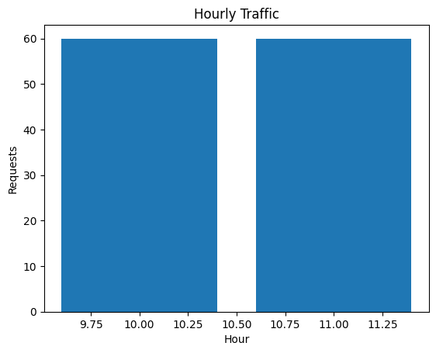  
  
  
import matplotlib.pyplot as plt

import numpy as np

# Suppose traffic['hour'] is int 0-23

fig, ax = plt.subplots(figsize=(10,6))

bars = ax.bar(traffic['hour'], traffic['count'], color="#4b8bbe")

# Set x-axis as all 0-23 to show gaps as zeros if any hours are missing in the data

ax.set_xticks(np.arange(0, 24, 1))

ax.set_xticklabels(np.arange(0, 24, 1))

ax.set_xlabel("Hour of Day", fontsize=14)

ax.set_ylabel("Number of Requests", fontsize=14)

ax.set_title("Hourly Web Traffic", fontsize=16, fontweight='bold')

ax.yaxis.grid(True, linestyle='--', alpha=0.7)

# Annotate bars

for bar in bars:

height = bar.get_height()

if height > 0:

ax.annotate('{}'.format(height),

xy=(bar.get_x() + bar.get_width() / 2, height),

xytext=(0,3), # 3 points vertical offset

textcoords="offset points",

ha='center', va='bottom', fontsize=10)

plt.tight_layout()

plt.show()

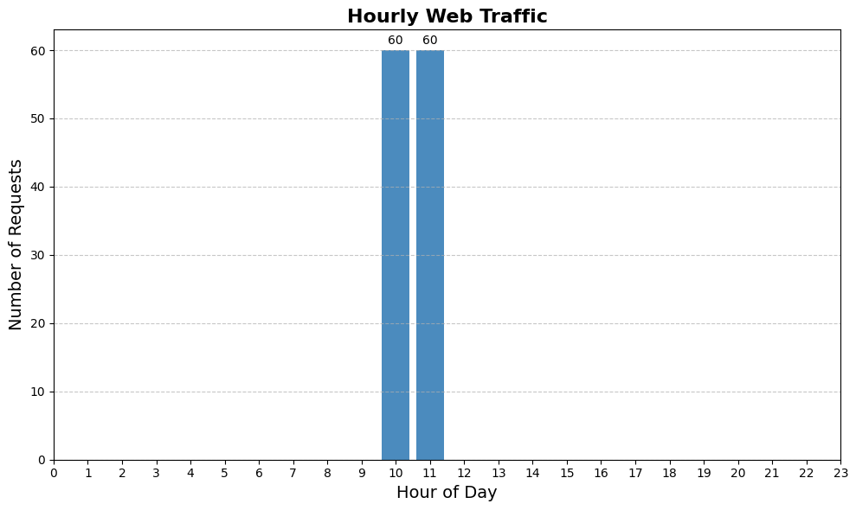  
  
  
  
  
  
  
status_counts = df.groupBy("status").count().orderBy("status").toPandas()

plt.figure(figsize=(8,5))

plt.bar(status_counts['status'].astype(str), status_counts['count'], color="#ec4d37")

plt.xlabel("HTTP Status Code", fontsize=13)

plt.ylabel("Count", fontsize=13)

plt.title("Requests per Status Code", fontsize=15, fontweight='bold')

plt.grid(axis='y', linestyle=':', alpha=0.6)

for idx, val in enumerate(status_counts['count']):

plt.text(idx, val+2, str(val), ha='center', fontsize=10)

plt.tight_layout()

plt.show()

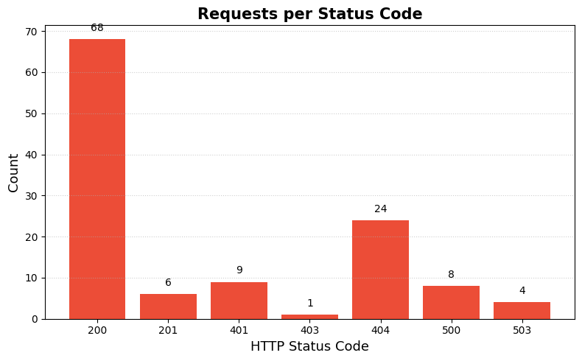top_urls = df.groupBy("url").count().orderBy("count", ascending=False).limit(10).toPandas()

plt.figure(figsize=(10,6))

bars = plt.barh(top_urls['url'], top_urls['count'], color="#64cc85")

plt.xlabel("Requests", fontsize=13)

plt.ylabel("URL", fontsize=13)

plt.title("Top 10 Requested URLs", fontsize=15, fontweight='bold')

plt.gca().invert_yaxis()

for bar in bars:

plt.text(bar.get_width()+2, bar.get_y()+bar.get_height()/2, str(int(bar.get_width())), va='center')

plt.tight_layout()

plt.show()

top_urls = df.groupBy("url").count().orderBy("count", ascending=False).limit(10).toPandas()

plt.figure(figsize=(10,6))

bars = plt.barh(top_urls['url'], top_urls['count'], color="#64cc85")

plt.xlabel("Requests", fontsize=13)

plt.ylabel("URL", fontsize=13)

plt.title("Top 10 Requested URLs", fontsize=15, fontweight='bold')

plt.gca().invert_yaxis()

for bar in bars:

plt.text(bar.get_width()+2, bar.get_y()+bar.get_height()/2, str(int(bar.get_width())), va='center')

plt.tight_layout()

plt.show()

from pyspark.sql.functions import col, coalesce, lit

# Reuse df_with_time which already has the 'hour' column extracted using PySpark

# Filter for error logs (status >= 400) using PySpark

error_df_spark = df_with_time.filter(col('status') >= 400)

# Calculate total requests per hour using PySpark

total_requests_per_hour_spark = df_with_time.groupBy('hour').count().orderBy('hour')

# Calculate error requests per hour using PySpark

error_requests_per_hour_spark = error_df_spark.groupBy('hour').count().orderBy('hour')

# Join the two DataFrames to calculate the error rate

# Use a left outer join from total requests to error requests to include hours with no errors

error_rate_by_hour_spark = total_requests_per_hour_spark.join(

error_requests_per_hour_spark,

on='hour',

how='left_outer'

).select(

total_requests_per_hour_spark.hour,

(coalesce(error_requests_per_hour_spark['count'], lit(0)) / total_requests_per_hour_spark['count']).alias('error_rate')

).orderBy('hour')

# Convert the result to pandas for plotting

error_by_hour_pandas = error_rate_by_hour_spark.toPandas()

import matplotlib.pyplot as plt

plt.figure(figsize=(10,6))

plt.plot(error_by_hour_pandas['hour'], error_by_hour_pandas['error_rate'], marker='o', color='#ffb800', label='Error Rate')

plt.xlabel("Hour of Day", fontsize=13)

plt.ylabel("Error Rate", fontsize=13)

plt.title("Error Rate by Hour", fontsize=15, fontweight='bold')

plt.ylim(0, 1)

plt.xticks(error_by_hour_pandas['hour']) # Ensure all hours with data are shown on x-axis

plt.grid(True, linestyle='--', alpha=0.6)

plt.legend()

plt.tight_layout()

plt.show()

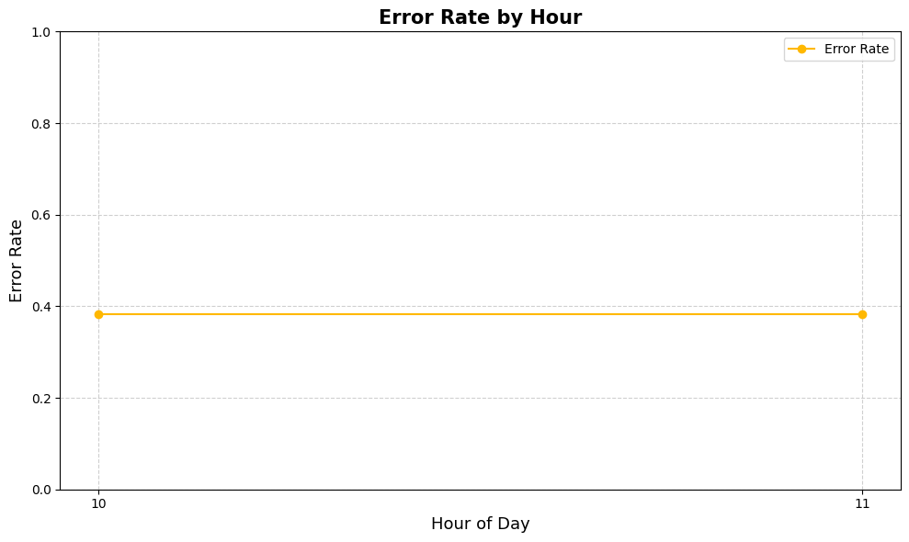top_ips = df.groupBy("ip").count().orderBy("count", ascending=False).limit(10).toPandas()

plt.figure(figsize=(7,7))

plt.pie(top_ips['count'], labels=top_ips['ip'], autopct='%1.1f%%', startangle=140, colors=plt.cm.Paired.colors)

plt.title("Top 10 Clients by Number of Requests", fontsize=15, fontweight='bold')

plt.tight_layout()

plt.show()

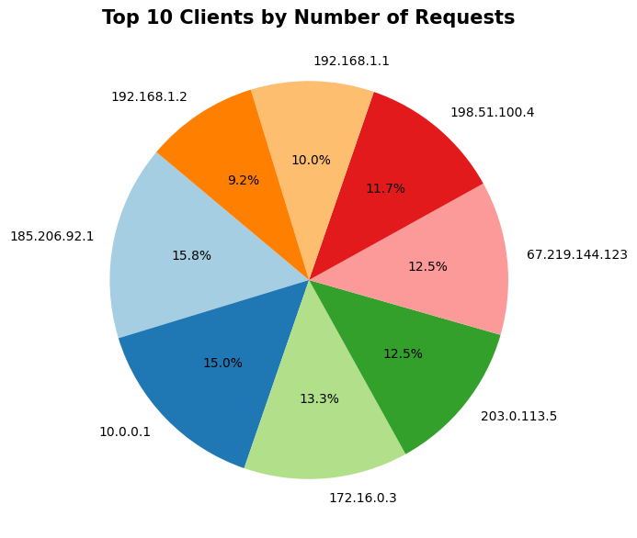

## 9. Output & Sample Results

*(Visualizations—bar charts, line graphs, and pie charts—can be added in this section.)*

* **Hourly Request Volume Table**: Shows the distribution of request counts per hour.
* **Status Code Distribution**: Provides a breakdown of response code frequencies (e.g., 200, 404, 500).
* **Top URLs Table**: Lists the most-requested resources.
* **Error Rate Table**: Presents hour-by-hour error percentages, highlighting timeframes of operational concern.
* **Anomaly Alerts**: Examples include alerts like "Error rate exceeded 10% in hour 12" for any window breaching predefined thresholds.

## 10. Conclusion & Future Work

The real-time log analysis pipeline successfully delivers:

* **Scalable, low-latency log ingestion and processing** for modern distributed systems.
* **Near-instant detection** of operational anomalies and error surges.
* **Efficient storage and historical analytics** using HDFS and Hive.
* **Actionable insights** through automatic aggregations and live metrics.

### Future Extensions

* Deployment of **advanced ML techniques** (e.g., deep learning or autoencoders) for complex anomaly and threat detection.
* Seamless **cloud integration** (AWS, Azure) for elasticity and managed scaling.
* **NLP-based log field extraction** and semantic classification.
* **Automated remediation actions** on critical alert triggers.

## 11. References

* **Abstract.pdf**: Project summary and breakdown of module design.
* **Algorithm.pdf**: Step-wise algorithm description and pseudocode.
* **Real_time_Log_Analysis_Using_Hadoop_and_Spark.ipynb**: Complete codebase, results, and prototype analytics.
* **Apache Spark, Hadoop, Kafka, Flume Official Documentation**.
* **Grafana, Kibana Documentation** for dashboard and visualization best practices.
* **Industry whitepapers** and **Cloudera/Databricks big data analytics guides**.  
    
    
    
    
  **Salendram Sowmya Sri  
  24M11MC153  
  Aditya University**